The Möbius Strip
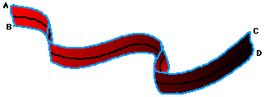
1. Start with a long rectangle (ABCD) made of paper.
2. Give the rectangle a half twist.
3. Join the ends so that A is matched with D and B is matched with C.
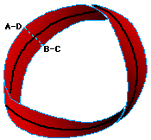
This curious surface is called a Möbius Strip or Möbius Band, named after August Ferdinand Möbius, a nineteenth century German mathematician and astronomer, who was a pioneer in the field of topology. Möbius, along with his better known contemporaries, Riemann, Lobachevsky and Bolyai, created a non-Euclidean revolution in geometry.
Möbius strips have found a number of surprising applications that exploit a remarkable property they possess: one-sidedness. Joining A to C and B to D (no half twist) would produce a simple belt-shaped loop with two sides and two edges -- impossible to travel from one side to the other without crossing an edge. But, as a result of the half twist, the Möbius Strip has only one side and one edge!
To demonstrate this, (1) start midway between the "edges" of a Möbius Strip and draw a line down its center; continue the line until you return to your starting point. Did you ever cross an edge? (2) Next, hold the edge of a Möbius Strip against the tip of a felt-tipped highlighter pen. Color the edge of the Möbius Strip by holding the highlighter still and just rotating the Mobius Strip around. Were you able to color the entire edge? (3) Now, with scissors cut the Mobius Strip along the center line that you drew. Then draw a center line around the resulting band, and cut along it. Did you predict what would happen?

The famous artist, M.C. Escher, used mathematical themes in some of his work, including a Möbius parade of ants. His flight of swans looks like it might be a Möbius Strip, but it's not. Can you see why not?
